Grosse Pointe Boat Club
Metro Beach Rendezvous
Come by boat or car!
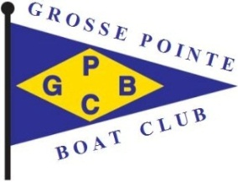
Saturday, July 20
Lake St. Clair (Metro Beach) Marina
Drinks (BYOB) at 4:30 pm, Dinner at 6:30 pm
Dinner: TBD

or bring our own main dish
Please bring an appetizer or dessert to share
Breakfast provided on Sunday morning

NOTE: Everyone must arrange their own overnight slips at the Marina!
Please go to https://www.midnrreservations.com. For reservation type click on “Harbor”, then scroll down and select “Lake St. Clair Marina”. Enter July 20 (July 19 if you want to arrive on Friday, as many will). Fill in your boat information. Click on Search, then south to find wells on a map. Pick an available well from 24 to 48 – South (let’s all try to get a well around 38), click reserve and continue to follow the directions. Enter credit card information to pay for your well; you should receive confirmation of your payment. When you are given the option for a comment, please indicate “Grosse Pointe Boat Club”.

Third annual par 3 golf (at least Don, Dale Cox, Chris and ?????) early Saturday afternoon.
Please call Paula @ 313-801-3250 or Don (313-801-3983), or email donald.smolenski@gmail.com or paula.smolenski@gmail.com
to notify us of your well assignment
Make your well reservations soon!

