The Grosse Pointe Boat Club
7th Annual WG Milliken State Park Rendezvous
Friday August 11--Sunday August 13, 2023
All are Welcome!
Come by Boat or Car

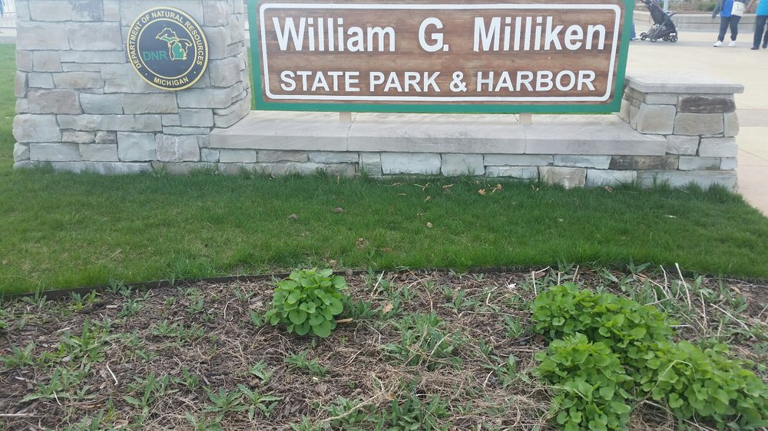
To reserve a Slip, club members must contact the DNR Call Center 1-800-447-2757 or go online www.midnrreservations.com.
Note: There is not a Group hold this year for boat slips. Everyone is encouraged to make their own reservations as soon as possible.
If you must contact the Harbor 313 396-0217
Saturday at 4 pm. Happy Hour bring your own Beverages and an Appetizer to pass.
Dinner- Make your Dinner plans on your own, there are several Restaurants in the area.
There are plenty of destinations if want to walk or rent a bike at the Marina.
The Dequindre Cut is a nice bike and walking trail takes you to the Eastern Market, the DNR Outdoor Adventure Center, or just walk along the Riverfront.
The Marina provides charcoal grills, restrooms, and showers.
Boat fees vary on size of boat.
The Harbor monitors Channel 9 for boaters.
NOTE: People traveling by car call me that weekend for the Gate Code.

If you can come, please notify.
PC Tom & Mary VanDerMaas
313 910-9290 or tom_vandermaas@hotmail.com
